
ACHARIYA ARTS AND SCIENCE COLLEGE
(Recognized under Section - 2f by the UGC Act, 1956)
(Affiliated to Pondicherry University)
Achariyapuram, Villianur, Puducherry – 605110
DEPARTMENT OF MATHEMATICS
Activities
2021-2022
. Webinar on 04.06.2021
The Department of mathematics Conducted Webinar on the Topic“ Application of Vedic Mathematics” by Dr.K.Thirumurugan on 04.06.2021 Welcome speech addressed Dr.D. Senthil Kumar HOD of Mathematics . Followed by Presidential address by Mr.K.RameshBabu Vice Principal.

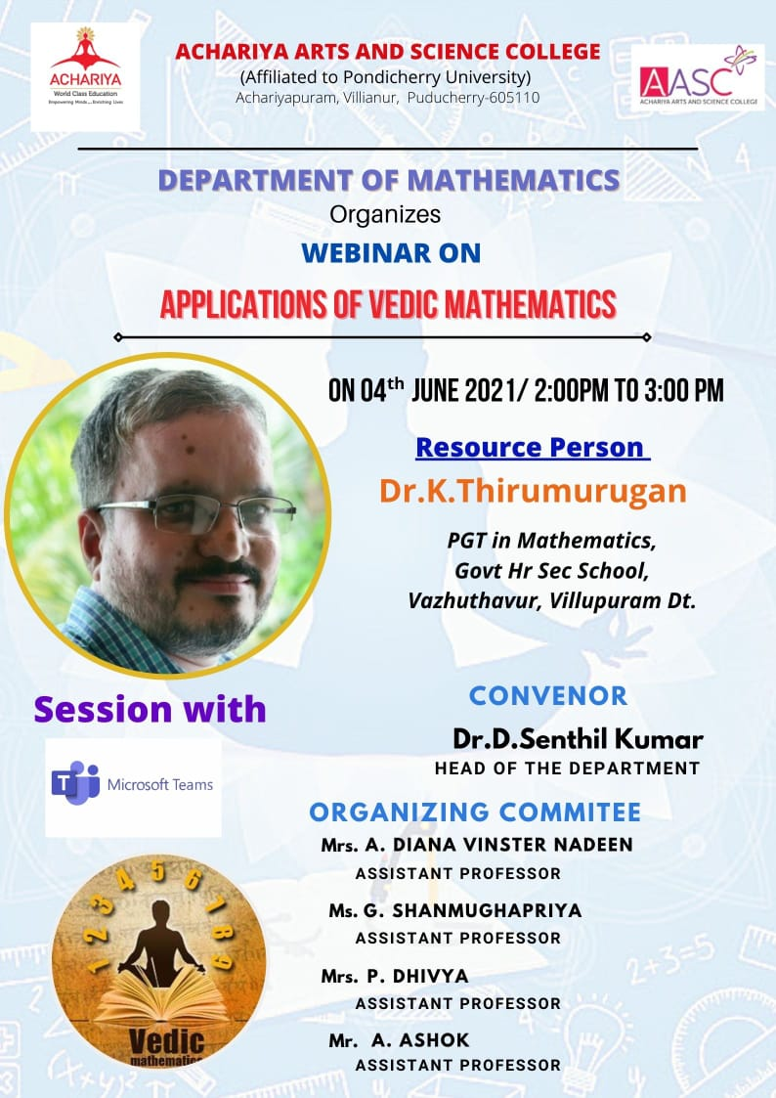
3. Webinar on 22.07.2021

The Department of mathematics Conducted Webinar on the Topic“ CARREER OPTIONS AFTER B.Sc MATHEMATICS ” by Mr.M.GNANASEKAR on 22.07.2021. Welcome speech addressed Dr.D. Senthil Kumar HOD of Mathematics . Followed by Presidential address by Mr.K.RameshBabu Vice Principal.

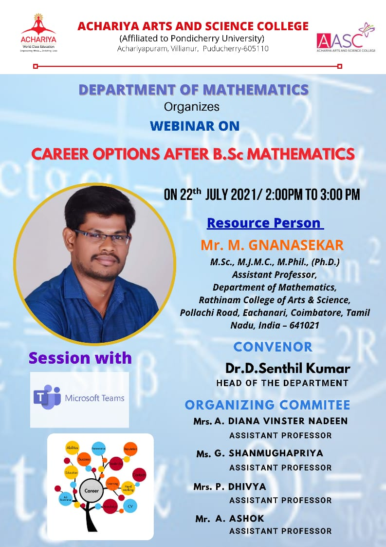

4. Webinar on 21.09.2021

The Department of mathematics Conducted Webinar on the Topic “Ready to be Extraordinary” by Mrs. Jayanthi Jais on 21.09.2021 Welcome speech addressed Dr.D. Senthil Kumar HOD of Mathematics . Followed by Presidential address by Mr.K.RameshBabu Vice Principal.

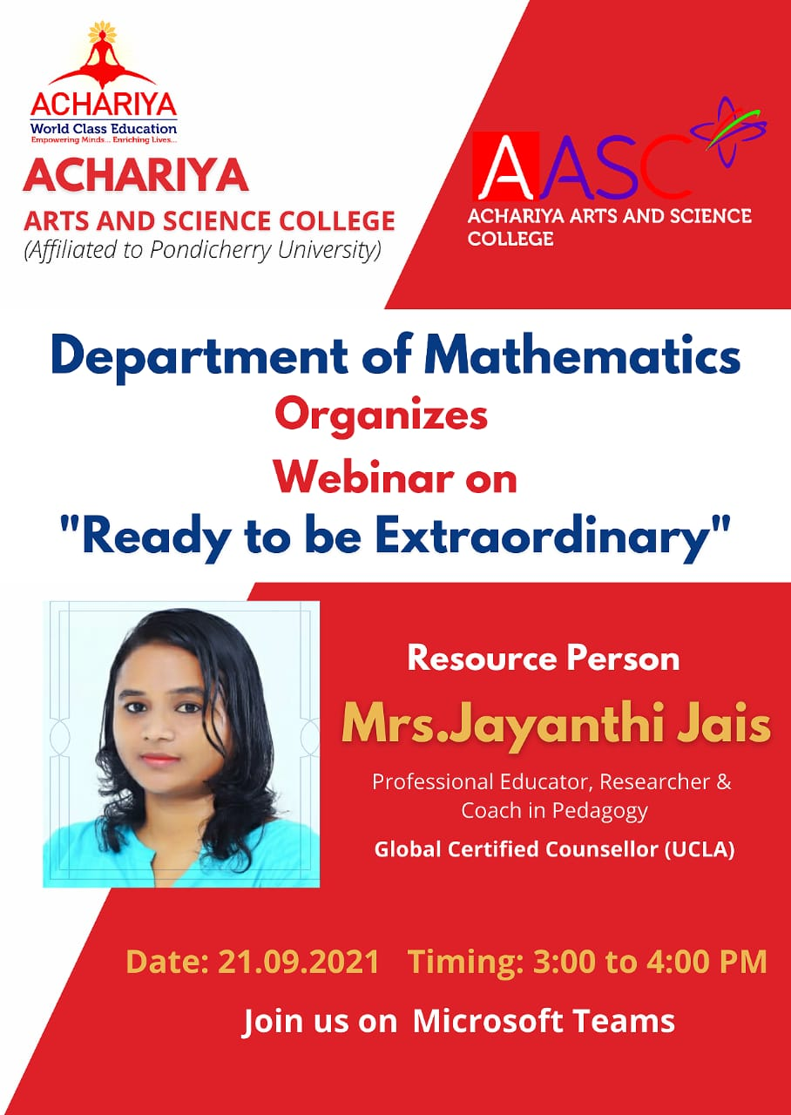

5. Two days National level work shop (SPSS)
The Department of mathematics organise two days National level work shop about SPSS program .1st day 06-12-2021 our 3rd student Ms.Abirami given the MC. Welcome speech addressed by Ms.Harine. Followed by Presidential address by Mr.K.RameshBabu Vice Principal. The Chief guest was Honour by our Vice Principal. The Principal was Honoured by Dr.D. Senthil Kumar HOD of Mathematics.
In Morning section,the chief guest given a Intro about Statistics. And the afternoon section Intro about SPSS program.Totally 100 students are participated . On behalf of the Department of Mathematics I extend my heart felt gratitude to our Beloved MD ji, Principal sir and Vice Principal sir for their support.
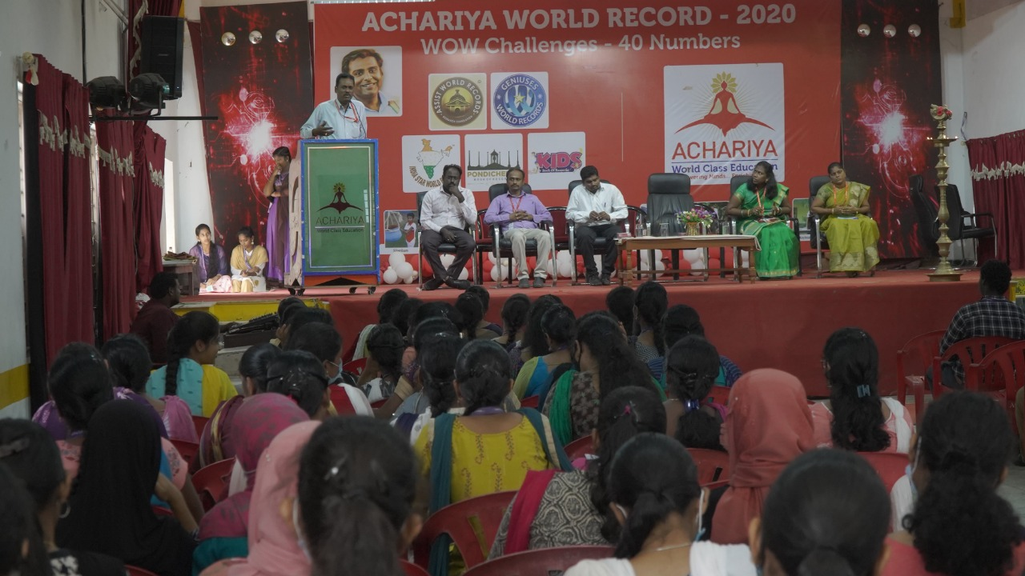
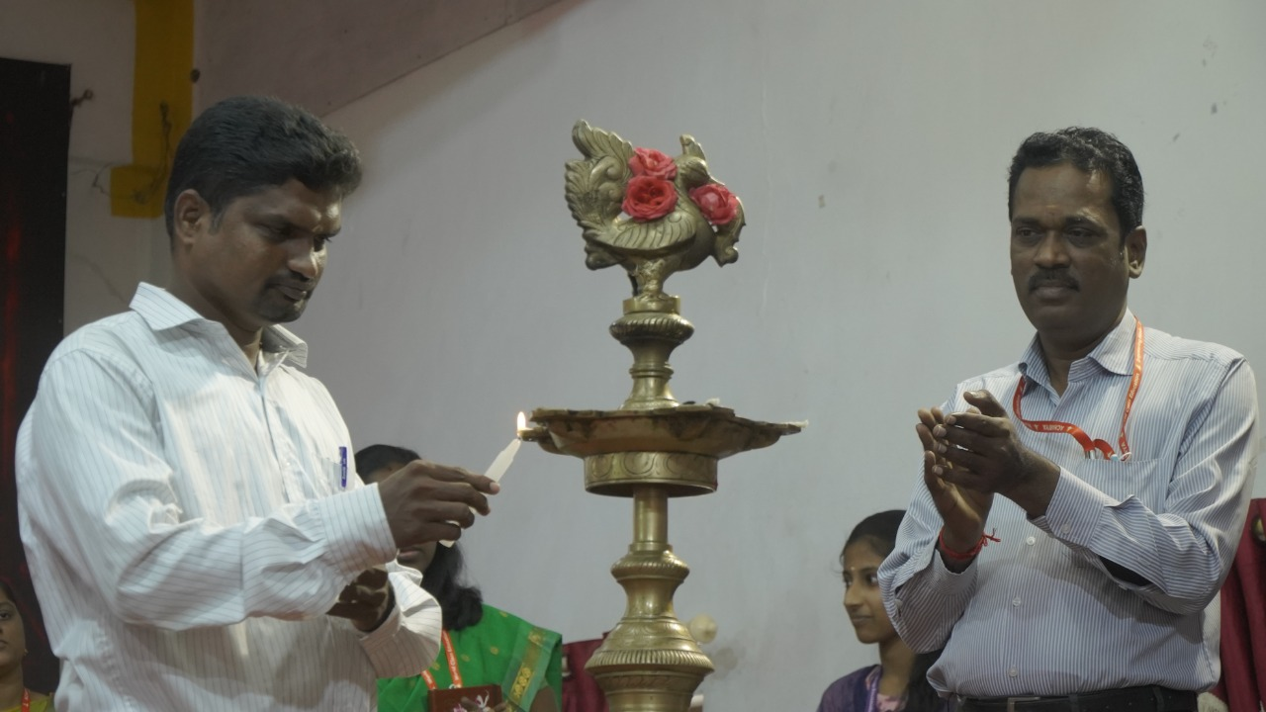
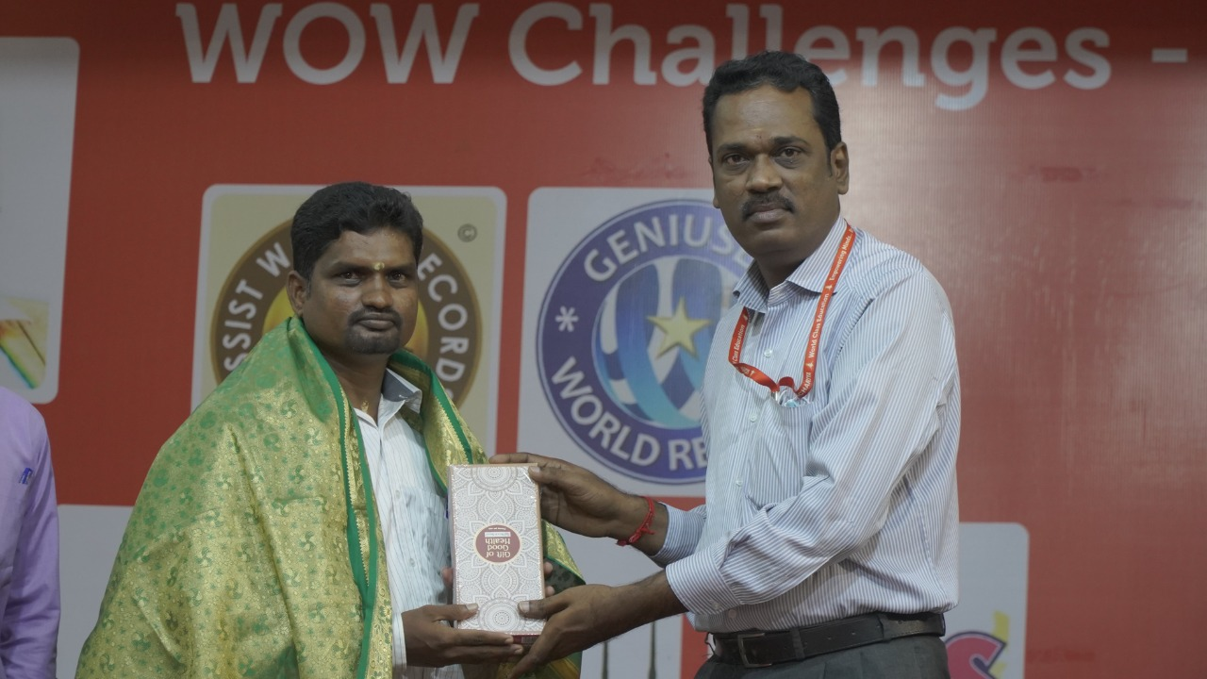
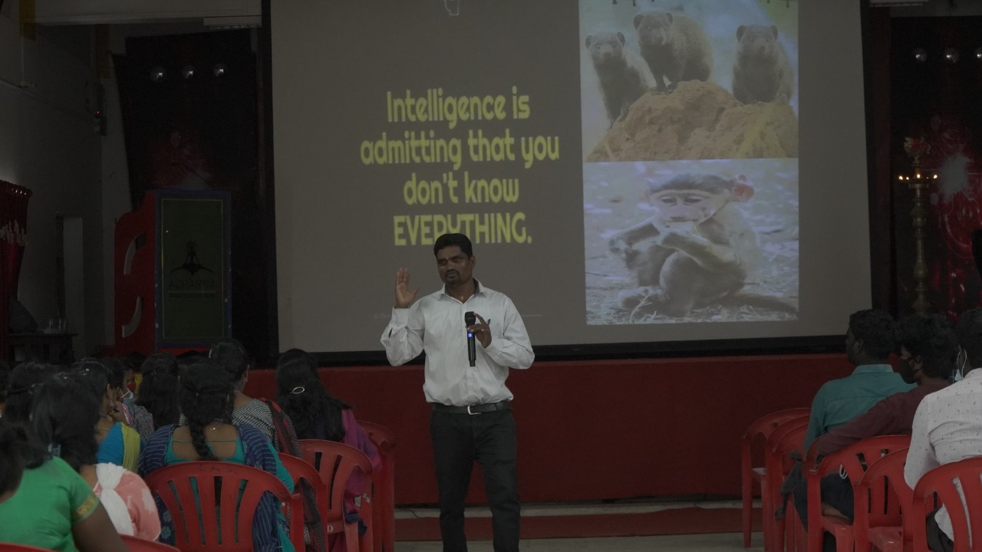

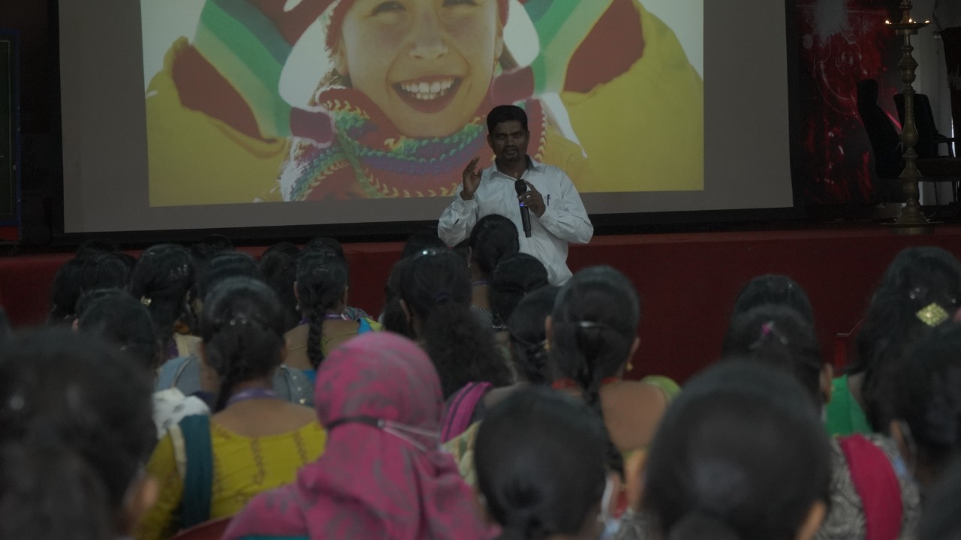

2nd day 07-12-202 Practical section in the IT Lab
In Morning section B.com ,BBA, students are attended the class And the afternoon section M.com, B.com (CS) , Maths, BSC (cs) dept. students are attended the class. Totally 100 students are participated . At end of Section certificate is given by the chief guest and vice principal On behalf of the Department of Mathematics I extend my heart felt gratitude to our Beloved MD ji, Principal sir and Vice Principal sir for their support. A special thanks to the Head, staff members and various department, Office and Maintenance for their support. At end of session certificate are given to the students.
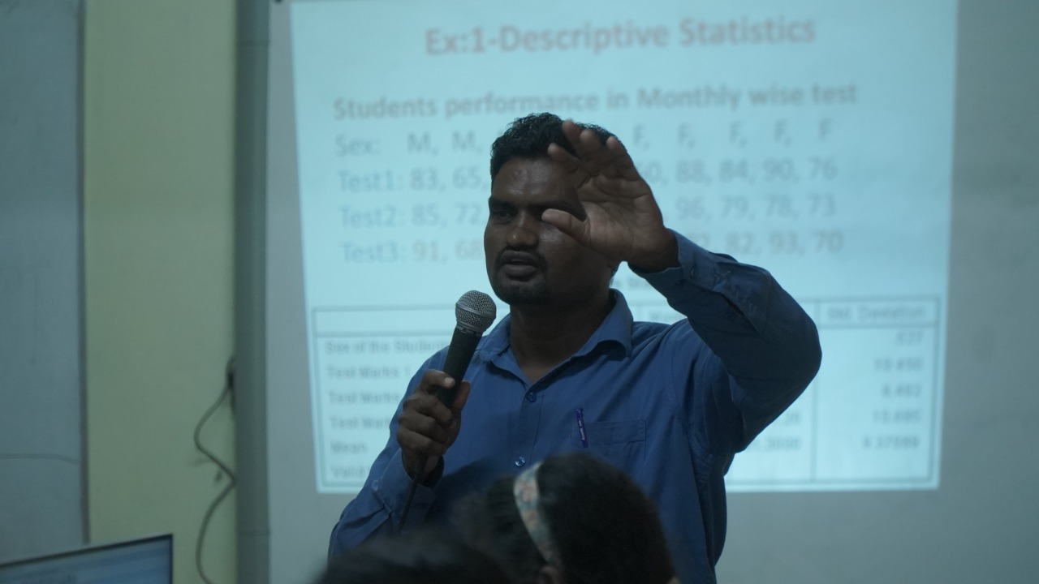
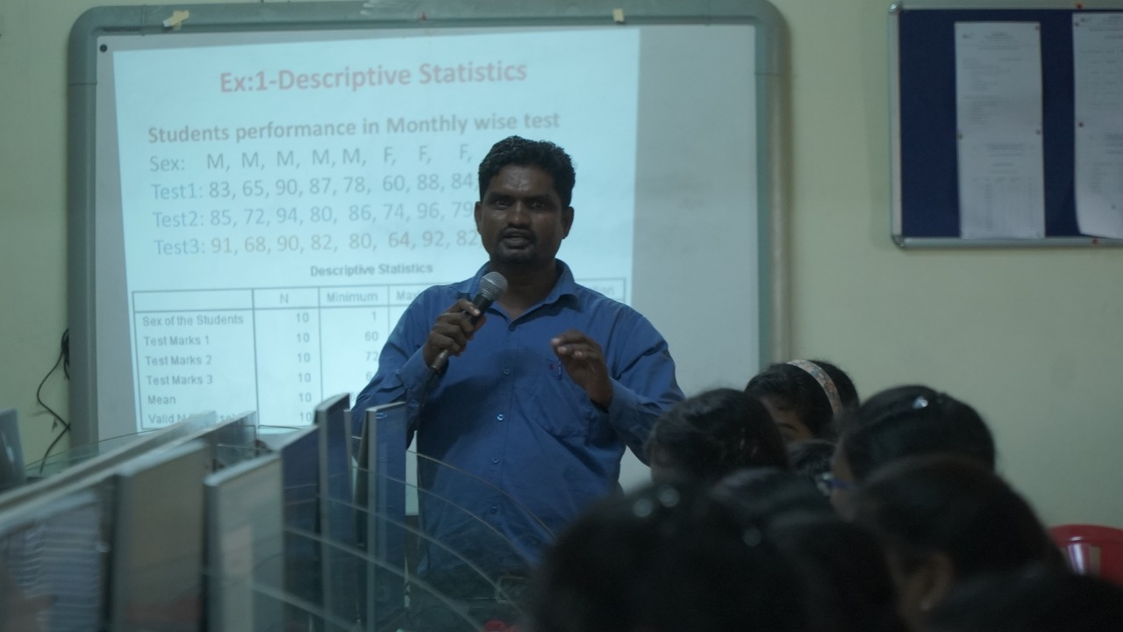
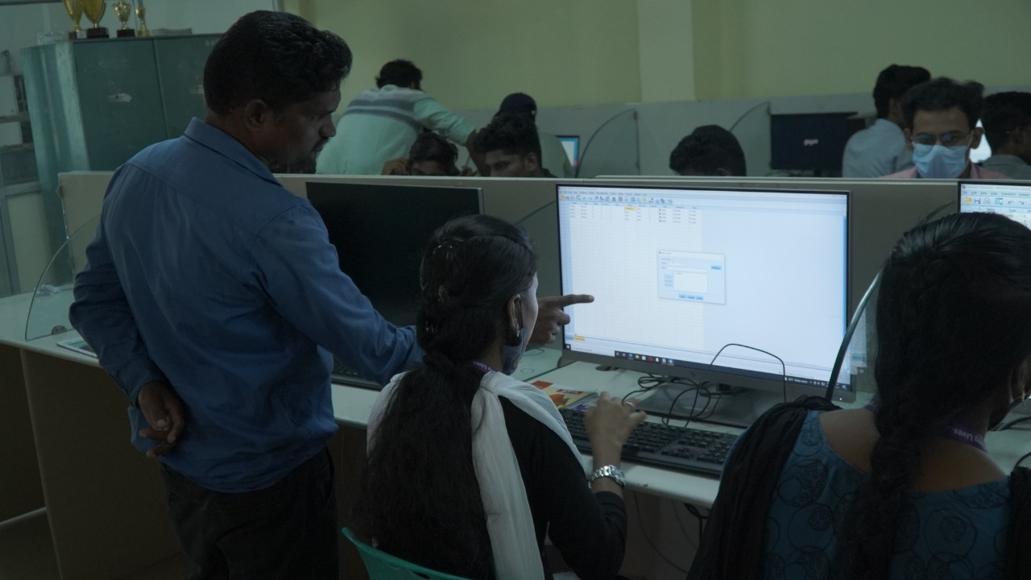
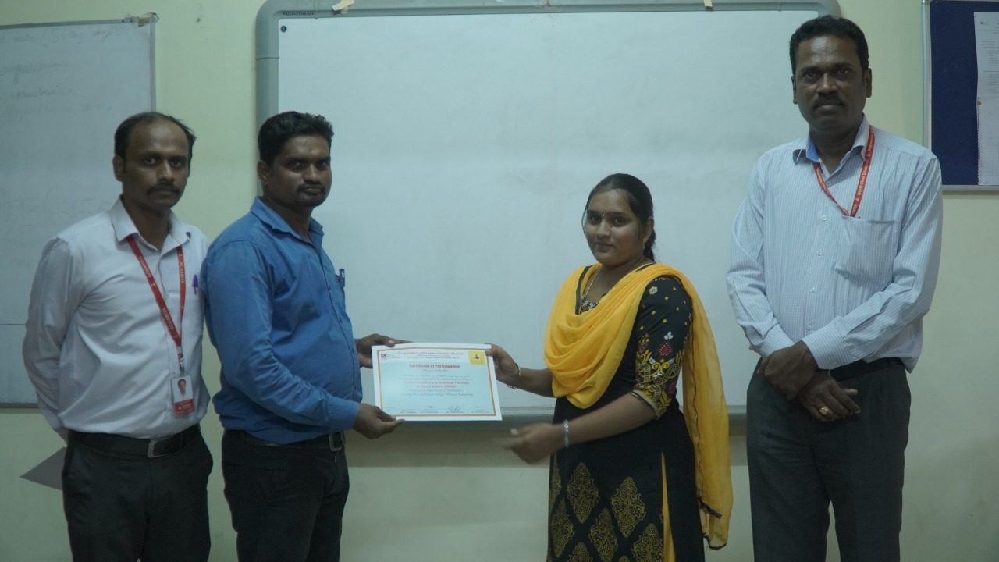
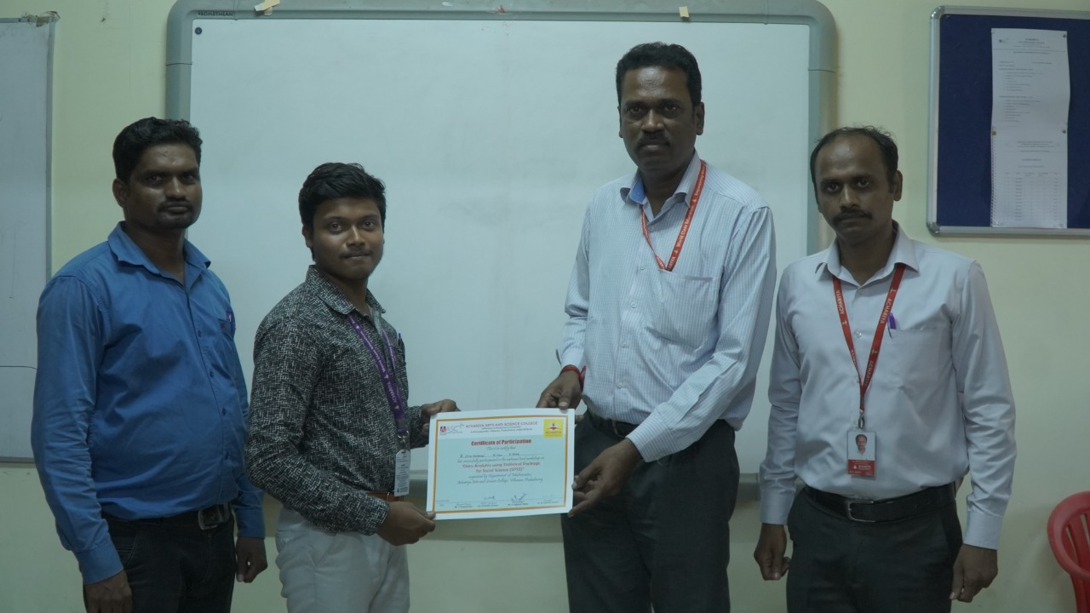
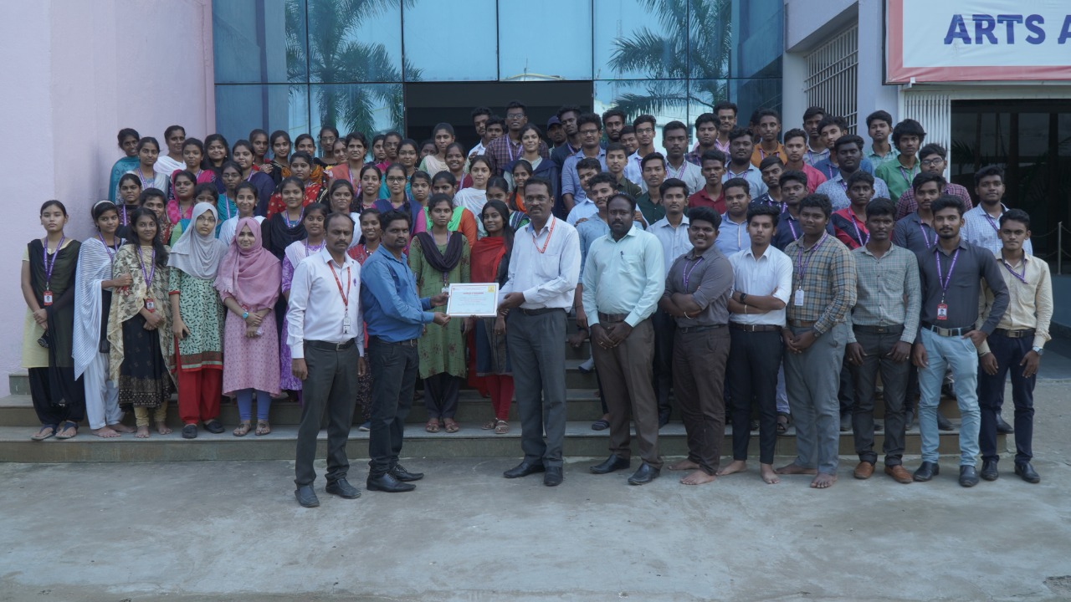

ACHARIYA ARTS AND SCIENCE COLLEGE
(Recognized under Section - 2f by the UGC Act, 1956)
(Affiliated to Pondicherry University)
Achariyapuram, Villianur, Puducherry – 605110

The Department of Mathematics have successfully conducted one day workshop on R programming. on 10.06.2022.The Head of the Department Dr.D.Senthil Kumar welcomed the gathering and introduced the Resource Person, Dr.S.Suresh, Assistant Professor in Statistics, University of Madras, who gave excellent lecture for the students, which enlighten the minds and paved way towards the field of research using mathematical tools.After the session, the chief guest distributed certificates to the students.Finally D.Harine , III B.Sc Mathematics, delivered vote of thanks.On this regard,we express our sincere gratitude to MD Sir, Dr.J.Aravindhan ji for his continuous encouragement and motivation, the Principal, Dr.S.Vimal Anand sir for his phenomenal support and guidance and the Heads of various departments, Faculty members and students for the uncoditional cooperation.
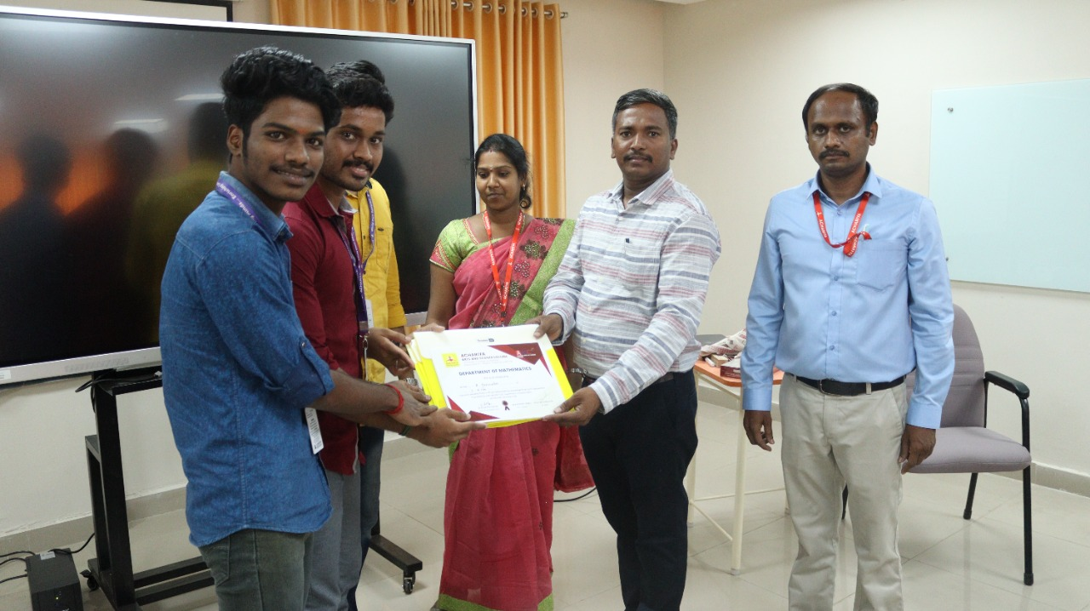
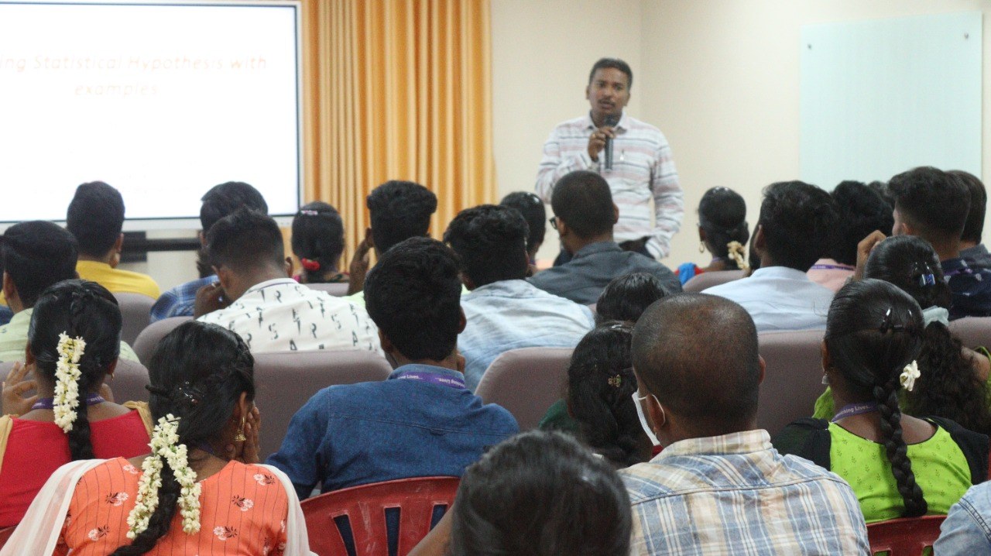

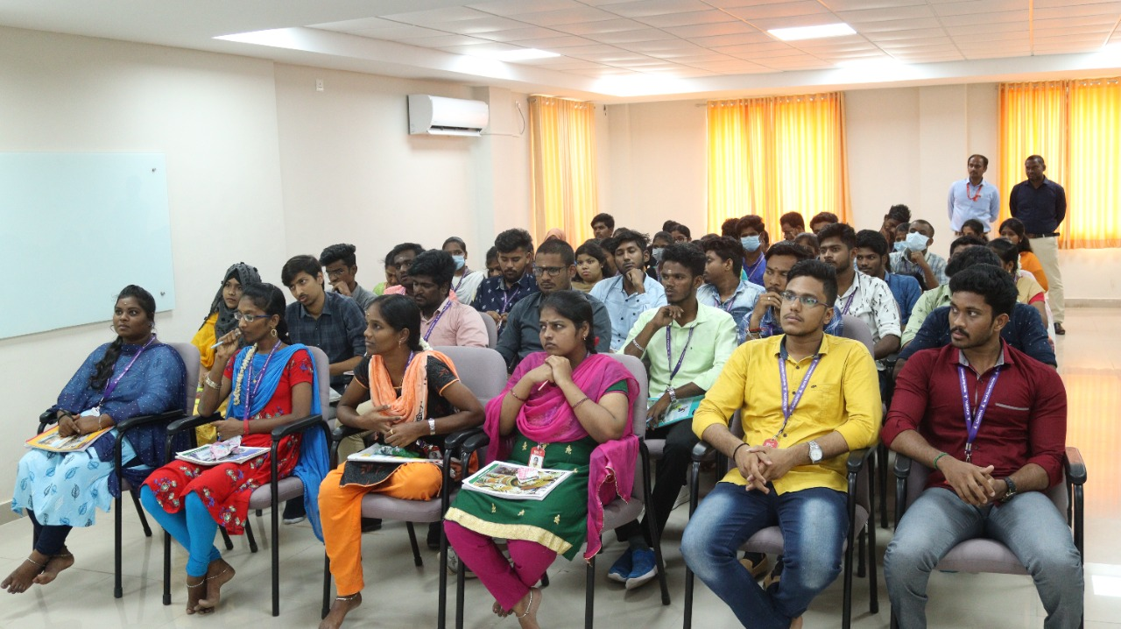

Event
- B.ABIRAMI, L. ANTONY LUMAN , D. HARINE , E. STEPHANRAJ and V. VIJAY won the Second price National Mathematics Day was Celebrated in Perunthalaivar Kamarajar Arts college, in Puducherry on 22-10-2021

